Checklist:
- Entire Document Font Style is: Timesnewroman
- All text content: Font Size: 11, Justify
- CHAPTER and HEADING OF CHAPTER in Uppercase, size 21
- Heading: Bold, Center 16
- Subheading: Bold, Center 15,14,13,etc
- Table and Figure Caption: below the table or figure
size: 12, italic, center
- Table content: size 10
- Figures and Tables should be justified, center aligned
- Figure and table number should be right. (3.5 means 5th figure in 3rd chapter. It should never be 3.4.2, etc)
- Lowfideility designs should be scanned and legibly viewed
- Keep one or two screens per page. Not more than two.
- Mindmap, mid and high fidelity should be downloaded and then copy pasted. Background should be transparent (not dotted backgroud) It should be viewed clearly.
- Add Page Numbers
- Every chapter should start in fresh page
- Testcases should have minimum 25 entries
- Abstract, conclusion, future enhancement should be 250 to 350 words
- Page number should be center aligned. (size 10)
- Delete this checklist

**********************
Project report submitted to the Karpagam Academy of Higher Education in partial fulfillment of the requirements for the award of the degree of
Master of Computer Applications

Submitted by
*************************
(Reg. No: *************)



Under the Guidance of
******************************
***************
Computer Applications

KARPAGAM ACADEMY OF HIGHER EDUCATION
(Deemed to be University)
(Established Under Section 3 of UGC Act, 1956)
(Accredited with A+ Grade by NAAC in the Second Cycle)
COIMBATORE – 641 021

APRIL - 2026

KARPAGAM ACADEMY OF HIGHER EDUCATION
(Deemed to be University)
(Established Under Section 3 of UGC Act, 1956)
(Accredited with A+ Grade by NAAC in the Second Cycle)
COIMBATORE – 641 021



MASTER OF COMPUTER APPLICATIONS

BONAFIDE CERTIFICATE

This is to certify that the project work entitled “*************” done by *********** (Reg. No: **********), during the period Dec 2025 to April 2026 in partial fulfillment of the degree of Computer Applications, is submitted for the viva-voce held on ______________

Project Guide Head of Department

INTERNAL EXAMINER EXTERNAL EXAMINER

KARPAGAM ACADEMY OF HIGHER EDUCATION
(Deemed to be University)
(Established Under Section 3 of UGC Act, 1956)
(Accredited with A+ Grade by NAAC in the Second Cycle)
COIMBATORE – 641 021
Master of Computer Applications

CERTIFICATE
This is to certify that the project entitled “*****************” is the bonafide project work carried out by *************** (Reg.No: *********), student of Computer Applications submitted to the Karpagam Academy of Higher Education, Coimbatore, during the academic year 2025-2026, in partial fulfillment of the requirements for the award of the Degree of Master of Computer Applications and is the record of student’s own work carried out by him under my supervision.

Place: Coimbatore Signature of the Guide
Date:

DECLARATION
I, ************ (Reg. No: **************), do hereby declare that this project work entitled “***************************” is submitted to the Karpagam Academy of Higher Education in partial fulfillment of the requirements for the award of the degree of Computer Applications (MCA) is a record of original project work done by me, during the period of Dec 2025 to March 2026 under the supervision and guidance of **********************************, ********************* and that it has not formed the basis for any Degree / Diploma or other similar title to any candidate of any university.

Place: Coimbatore Signature of the candidate

Date:

ABSTRACT
This page should have 250 to 350 words in a single paragraph about your project. Mention what are the functionality you have in this and what is your contribution. Who will be benefited. What is your role, etc. also tell what is the implementation you have used. Drive Now is a web-based car rental application designed to simplify vehicle discovery, booking, and rental management through an easy-to-use digital interface. The source project content describes it as a React-based system supported by JSON Server and modern UI practices, while the sample format defines a structured academic project report with chapters for introduction, analysis, design, implementation, testing, and conclusion.
This document reorganizes and condenses the original material into an aligned academic format suitable for a report of about 25 to 35 pages. The content is reduced from the larger source document and rewritten into clear, structured sections that follow the sample index pattern.

ACKNOWLEDGEMENT

Table of Content
Chap No. | Sub Sec | Title
1 | Introduction
 | 1.1 | Overview
 | 1.2 | Background
 | 1.3 | Problem Statement
 | 1.4 | Proposed Solution
 | 1.5 | Objectives
2 | System Analysis
 | 2.1 | Identification of Need
 | 2.2 | Feasibility Study
 | 2.3 | Project Planning with Mind map
 | 2.4 | Software requirement specifications (SRS)
2.4.1Functional Requirements
2.4.1.1 System Feature1
2.4.1.2 System Feature2
 |  | 2.4.2 External Interface Requirements
 |  | 2.4.2.1 Hardware Interface
 |  | 2.4.2.2 Software Interface
2.4.3 Technical Requirements
2.4.3.1 Performance
2.4.3.2 Scalability
2.4.3.3 Security
2.4.3.4 Maintainability
2.4.3.5 Usability
2.4.3.6 Availability
 | 2.5 | Use-case Diagram

ChaNo. | Sub Sec | Title
3 | System Design
 | 3.1 | Module Design  3.1.1 Module Design Description  3.1.2 Module plan  3.1.3 CRUD Mapping
 | 3.2 | API design  3.2.1 API Schema  3.2.2 API Sample
 | 3.3 | File Schema Design
 | 3.4 | User Interface Design  3.4.1 Low fidelity Design  3.4.2 Medium fidelity Design  3.4.3 High fidelity Design
 | 3.5 | Testcases
4 | Implementation
 | 4.1 | Source code of index.js
 | 4.2 | Sample source code of validation
 | 4.3 | Sample source code of CRUD Operation
 | 4.4 | Sample source code of SEO Optimization
5 | Results and Discussions
6 | Conclusion
7 | Future Enhancement
8 | References

LIST OF TABLES

TABLE No. | TABLE NAME
3.1 | Module Description Table
3.2 | CRUD Mapping Table
3.3 | Testcase

LIST OF FIGURES
Figure No. | Figure Name
2.1 | Mind map
3.1 | Low Fidelity of Login Screen
3.2 | Low Fidelity of Home Screen
3.3 | Low Fidelity of Fleet Screen
3.4 | Low Fidelity of Bookings Screen
3.5 | Low Fidelity of Admin Screen
3.6 | Low Fidelity of About Screen
3.7 | Low Fidelity of Contact us Screen
3.8 | Mid fidelity of login screen
3.9 | Mid fidelity of home screen
 | Mid Fidelity of Fleet Screen
 | Mid Fidelity of Bookings Screen
 | Mid Fidelity of Admin Screen
 | Mid Fidelity of About Screen
 | Mid Fidelity of Contact us Screen
 | High fidelity of login screen
 | High fidelity of home screen
 | High Fidelity of Fleet Screen
 | High Fidelity of Bookings Screen
 | High Fidelity of Admin Screen
 | High Fidelity of About Screen
 | Output1: Login Screen
 | Output2: Landing Page

Figure No. | Figure Name
 | Output: HomeScreen

CHAPTER 1

INTRODUCTION
1.1 Overview
Drive Now is an online car rental management system that allows users to browse available cars, view details, complete bookings, and interact with a responsive user interface. The project content states that the system is built using React [1] and JSON Server[2], with emphasis on usability, workflow clarity, maintainability, and performance.
The application aims to replace slow manual rental procedures with a faster and more transparent digital process. It supports organized presentation of vehicles, customer interaction, and booking flow through a modern web application structure.
1.2 Background
Traditional vehicle rental processes often depend on phone calls, paper records, or unstructured local systems that make booking and management inefficient. The sample format expects the background section to explain the topic context and state of the field, which fits a transition from manual rental services to web-based booking platforms.
A modern rental system is expected to provide convenient search, booking confirmation, service visibility, and better administrative control. The source document positions Drive Now as a practical implementation using commonly used frontend tools and simple backend simulation for academic project development.
1.3 Problem Statement
Customers often face delays in checking vehicle availability, understanding pricing, and completing reservations in conventional rental environments. Service providers also struggle with maintaining organized records, updating car status, and handling repeated customer requests efficiently.
The project addresses the need for a centralized and user-friendly platform that reduces manual effort and improves the booking experience. The sample format explicitly requires the problem to be explained clearly, so this section focuses on operational inefficiency, poor accessibility, and lack of systemized booking support.

1.4 Proposed Solution
The proposed solution is a web-based car rental application named Drive Now. It provides digital browsing of cars, presentation of vehicle details, reservation workflow, and a structured interface that can be extended with admin and data management capabilities.[1]
Compared with manual handling, the proposed method improves speed, consistency, and user experience. It also offers an organized technical foundation using React for the frontend and JSON Server for lightweight data handling during development and demonstration.[1]
1.5 Objectives
The main objectives of the project are:
- To create a simple and responsive car rental platform for users.
- To display vehicle information in a structured and attractive manner.
- To support smooth booking and rental interaction.
- To improve record handling compared with manual methods.
- To build a maintainable academic project using modern web technologies.[1][2]

CHAPTER 2
SYSTEM ANALYSIS
2.1 Identification of Need
A digital rental system is needed because customers expect quick online access to services and businesses require efficient handling of bookings and car availability. The sample structure asks why the problem should be solved, and the answer lies in improving service speed, reducing confusion, and increasing process transparency.
Drive Now meets this need by combining a user-focused interface with organized data presentation. It supports both customer convenience and easier operational management in a single platform.[1]
2.2 Feasibility Study
The project is technically feasible because it uses accessible development tools such as React and JSON Server. These technologies are suitable for academic implementation, rapid prototyping, and frontend-driven demonstrations.[1]
The project is operationally feasible because users are already familiar with web-based service platforms. It is also economically feasible for student development because the software stack is lightweight and does not require costly infrastructure for a prototype-level implementation.[1]
2.3 Project Planning with Mind Map
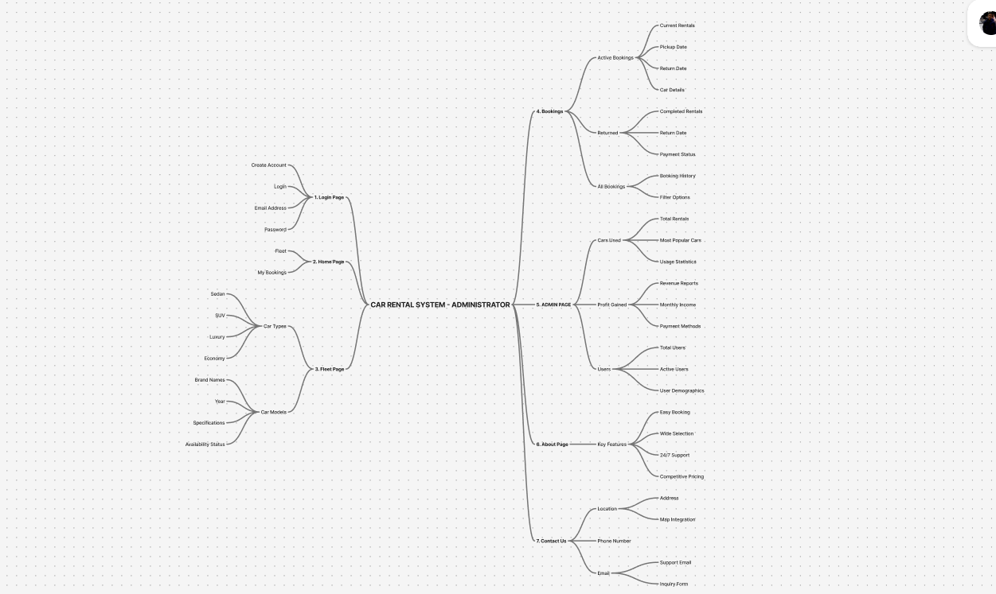
Wrong way to have image

2.3 Project Planning with Mind Map
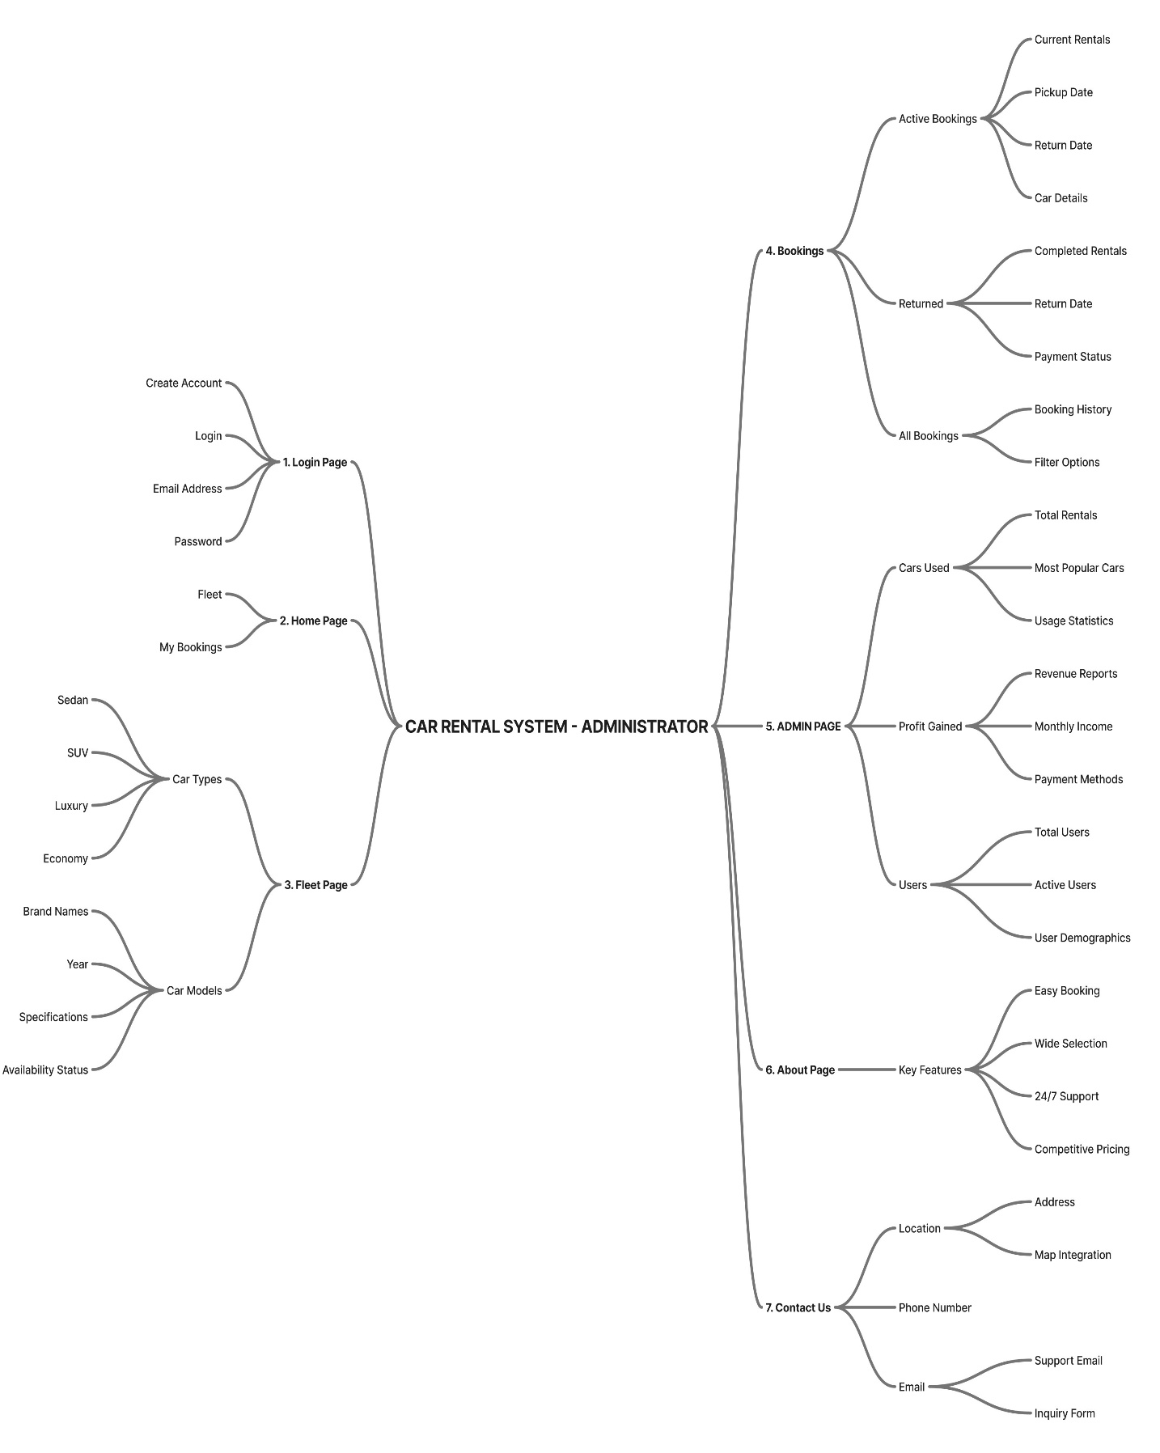
Figure 2.1. Mindmap for Car Rental System

2.4 Software Requirement Specification
2.4.1 Functional Requirements
The system should allow users to view the home page, browse available cars, inspect car details, and make booking-related interactions. The project source repeatedly describes user interaction, workflow handling, architecture details, and system behavior centered on a car rental platform.
Additional expected functions include category-based viewing, navigation across pages, and structured data display. At an extended level, the system can support login, booking confirmation, rental history, and administrative update features.
2.4.2 External Interface Requirements
2.4.2.1. Hardware Interface:
On the client side, the system requires a computer or mobile device capable of running a modern browser. On the server side, a development environment that can run the frontend application and JSON Server is sufficient for the academic prototype.
2.4.2.2. Software Interface:
The frontend is implemented with React, while JSON Server is used to simulate backend data interaction in the project documentation. A web browser acts as the primary access interface for both users and project evaluators.
2.4.3 Technical Requirements
The sample format lists performance, scalability, security, maintainability, usability, and availability as core technical parameters.
For Drive Now, performance depends on responsive page rendering and smooth navigation; scalability relates to adding more cars, users, and modules; security concerns include safe handling of user actions and future authentication; maintainability is supported by modular frontend development; usability is strengthened by modern UI design; and availability depends on consistent application hosting during deployment or demonstration.
2.4.3.1 Performance
Give 4 lines to 10 lines as a paragraph
2.4.3.2 Scalability
Give 4 lines to 10 lines as a paragraph
2.4.3.3 Security
Give 4 lines to 10 lines as a paragraph

2.4.3.4 Maintainability
Give 4 lines to 10 lines as a paragraph
2.4.3.5 Usability
Give 4 lines to 10 lines as a paragraph

2.4.3.6 Availability
Give 4 lines to 10 lines as a paragraph

2.5 Usecase Diagram
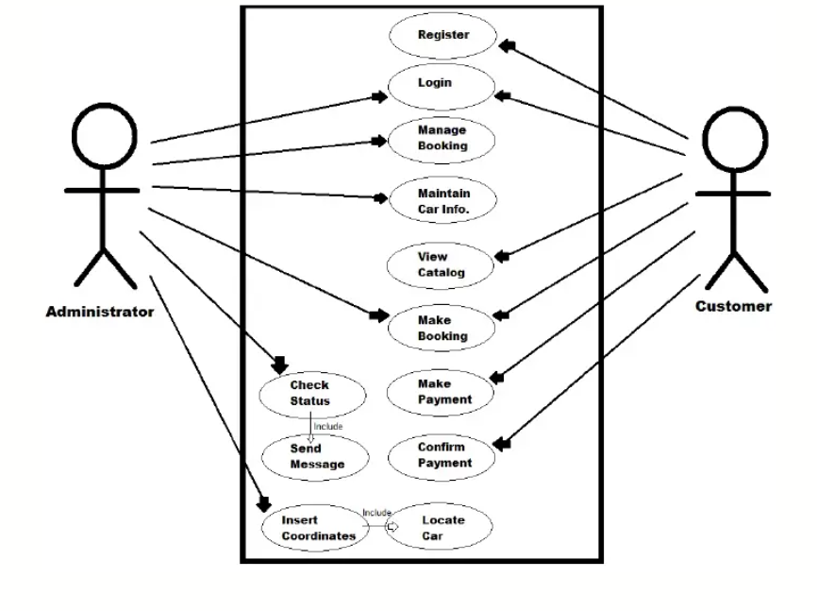
Figure 2.2. Usecase diagram for Car Rental System

CHAPTER 3
SYSTEM DESIGN
3.1 Module Design
3.1.1. Module Design Description
The application can be divided into modules such as Home, Car Listing, Car Details, Booking, User Management, and Admin Control. The sample structure requires proper modularization and specification of each module, which suits the frontend-oriented structure described in the source document.
Each module has a defined responsibility: browsing vehicles, displaying detailed information, collecting booking input, and managing data display. This improves readability, maintainability, and future expansion.

3.1.2. Module Design Plan
Module Name | Description | Input | Output | Functional Component File Name
Sign up |  | Email id, name, phone, password | Login Successful
Table 3.1: Module Design Plan

3.1.2 CRUD Operation Plan
Module | Create | Update | Delete | View
Sign up | Email id, name, phone, password | password | Email Id | NA
Table 3.2: Module Design Plan
3.2 API Design
3.2.1 API SCHEMA
3.2.1.1 API for Login Module
{id, name, password}
3.2.1.2 API for Booking Module
{id, name, model, type, seats, fuel, transmission, price, year, mileage, re, color, features, status}
3.2.1.3 API for Manage Car Module
{id, name, model, type, seats, fuel, transmission, price, year, mileage, re, color, features, status}
3.2.2 Sample API
3.2.2.1 API for Login Module
3.2.2.2 API for Booking Module
3.2.2.3 API for Manage Car Module
const CARS = [ { id:1, name:"Tesla Model 3", type:"Electric", seats:5, fuel:"Electric", transmission:"Automatic", price:3500, year:2023, mileage:"0 km", reg:"TN-09-EV-0031", color:"Pearl White", img:"https://images.unsplash.com/photo-1560958089-b8a1929cea89?w=600&q=80", features:["Autopilot","360° Camera","Wireless Charging","FSD Ready"], status:"available" }, { id:2, name:"BMW 5 Series", type:"Luxury Sedan", seats:5, fuel:"Petrol", transmission:"Automatic", price:4200, year:2022, mileage:"12,000 km", reg:"TN-07-BM-5522", color:"Sapphire Black", img:"https://images.unsplash.com/photo-1555215695-3004980ad54e?w=600&q=80", features:["Sunroof","HUD Display","Heated Seats","Harman Kardon"], status:"available" }, { id:3, name:"Toyota Fortuner", type:"SUV", seats:7, fuel:"Diesel", transmission:"Manual", price:2800, year:2022, mileage:"18,000 km", reg:"TN-07-TF-3301", color:"Phantom Grey", img:"https://images.unsplash.com/photo-1519641471654-76ce0107ad1b?w=600&q=80", features:["4WD","360° Camera","7-Seater","Cruise Control"], status:"rented" }, ];

3.3 File Schema Design
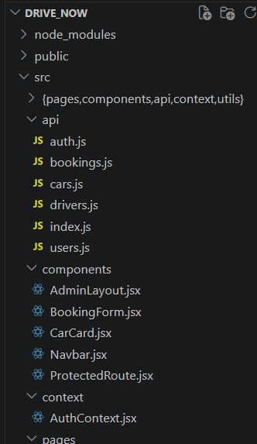
Figure 3.3: File Schema Description

File Schema Description
Folder Path with File name | Content Description
src/component/BookingForm.jsx | The modules have functional components like conform booking, delete booking, update booking and display booking components.
Table 3.3: File Schema Description

3.4 User Interface Design
3.4.1. Low fidelity Design
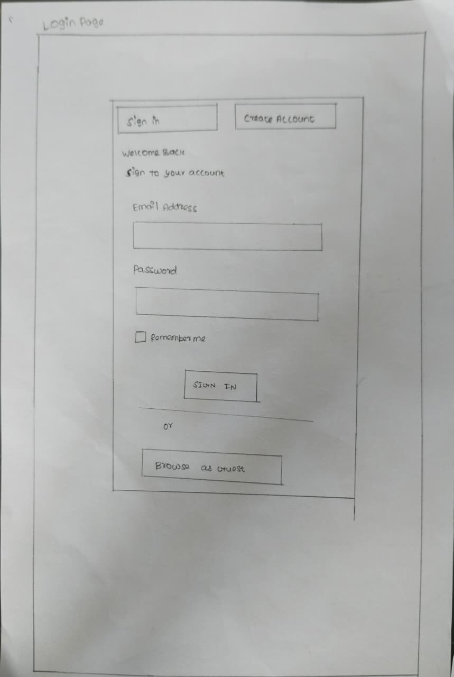
Figure 3.2 Low fidelity design of Login Page

3.4.2 Mid fidelity Design
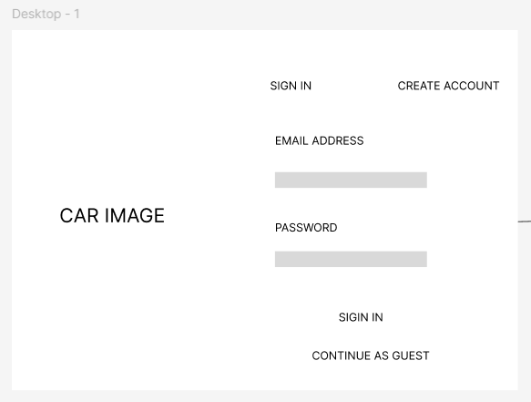
Figure 3.3 Mid fidelity design of Login Page

3.4.3 High fidelity Design
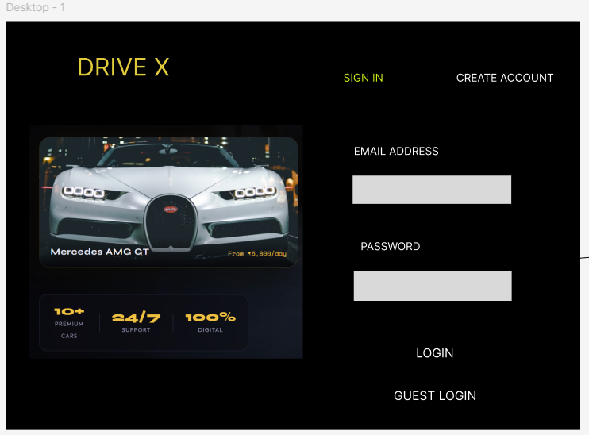
Figure 3.4: fidelity design of Login Page

3.5 Test Cases
TCID | Module | Input | Expected Output | Status
TC101 | Login | {name, } | Missing Credential | Fail
TC102 | Login | {name,password} | Login Successful | Pass
Minimum 25
Table 3.4: Testcases

CHAPTER 4
IMPLEMENTATION
4.1 Source code of index.js
4.2 Sample Source code of validation
4.3 Source code of CRUD Operation
Filename with path:
Sample Code:
const CARS = [
{
id:1, name:"Tesla Model 3", type:"Electric", seats:5, fuel:"Electric",
transmission:"Automatic", price:3500, year:2023, mileage:"0 km",
reg:"TN-09-EV-0031", color:"Pearl White",
img:"https://images.unsplash.com/photo-1560958089-b8a1929cea89?w=600&q=80",
features:["Autopilot","360° Camera","Wireless Charging","FSD Ready"],
status:"available"
},
{
id:2, name:"BMW 5 Series", type:"Luxury Sedan", seats:5, fuel:"Petrol",
transmission:"Automatic", price:4200, year:2022, mileage:"12,000 km",
reg:"TN-07-BM-5522", color:"Sapphire Black",
img:"https://images.unsplash.com/photo-1555215695-3004980ad54e?w=600&q=80",
features:["Sunroof","HUD Display","Heated Seats","Harman Kardon"],
status:"available"
},
{
id:3, name:"Toyota Fortuner", type:"SUV", seats:7, fuel:"Diesel",
transmission:"Manual", price:2800, year:2022, mileage:"18,000 km",
reg:"TN-07-TF-3301", color:"Phantom Grey",
img:"https://images.unsplash.com/photo-1519641471654-76ce0107ad1b?w=600&q=80",
features:["4WD","360° Camera","7-Seater","Cruise Control"],
status:"rented"
},
{
id:4, name:"Mercedes C200", type:"Luxury", seats:5, fuel:"Petrol",
transmission:"Automatic", price:5800, year:2023, mileage:"5,000 km",
reg:"TN-09-MB-2023", color:"Obsidian Black",
img:"https://images.unsplash.com/photo-1618843479313-40f8afb4b4d8?w=600&q=80",
features:["Burmester Sound","Massage Seats","MBUX AI","Night Vision"],
status:"available"
},
{
id:5, name:"Hyundai Creta", type:"Compact SUV", seats:5, fuel:"Petrol",
transmission:"Automatic", price:1900, year:2023, mileage:"8,000 km",
reg:"TN-21-HC-9901", color:"Fiery Red",
img:"https://images.unsplash.com/photo-1503376780353-7e6692767b70?w=600&q=80",
features:["Panoramic Roof","Ventilated Seats","ADAS","Bose Audio"],
status:"available"
},
{
id:6, name:"Maruti Swift", type:"Hatchback", seats:5, fuel:"Petrol",
transmission:"Manual", price:1200, year:2022, mileage:"15,000 km",
reg:"TN-04-MS-7722", color:"Arctic White",
img:"https://images.unsplash.com/photo-1541899481282-d53bffe3c35d?w=600&q=80",
features:["SmartPlay Studio","Reverse Camera","Dual Airbags"],
status:"maintenance"
},
{
id:7, name:"Kia EV6", type:"Electric", seats:5, fuel:"Electric",
transmission:"Automatic", price:4500, year:2023, mileage:"3,000 km",
reg:"TN-09-KE-0072", color:"Moonscape",
img:"https://images.unsplash.com/photo-1593941707882-a5bba14938c7?w=600&q=80",
features:["800V Charging","AR HUD","Matrix LED","Meridian Sound"],
status:"available"
},
{
id:8, name:"Honda City", type:"Sedan", seats:5, fuel:"Petrol",
transmission:"Manual", price:1800, year:2022, mileage:"10,000 km",
reg:"TN-07-HC-8802", color:"Lunar Silver",
img:"https://images.unsplash.com/photo-1590362891991-f776e747a588?w=600&q=80",
features:["Sunroof","LaneWatch","Honda Sensing","Wireless AA"],
status:"available"
},
{
id:9, name:"Tata Nexon EV", type:"Electric SUV", seats:5, fuel:"Electric",
transmission:"Automatic", price:2200, year:2023, mileage:"6,000 km",
reg:"TN-22-TN-0023", color:"Intensi-Teal",
img:"https://images.unsplash.com/photo-1647516878928-3e0d73d2ed65?w=600&q=80",
features:["400km Range","OTA Updates","Air Purifier","JBL Sound"],
status:"available"
},
{
id:10, name:"Mahindra Thar", type:"Off-Road", seats:4, fuel:"Diesel",
transmission:"Manual", price:2500, year:2023, mileage:"7,500 km",
reg:"TN-05-MT-2023", color:"Napoli Black",
img:"https://images.unsplash.com/photo-1583121274602-3e2820c69888?w=600&q=80",
features:["4x4 Low","Convertible Top","Rock Mode","Adventure Stats"],
status:"available"
}
];

const BOOKINGS = [
{
id:"BK10001", carId:3, carName:"Toyota Fortuner",
customer:"Arjun Mehta", phone:"9876543210", email:"arjun@email.com", license:"TN-0120230001",
from:"2025-03-20", to:"2025-03-23", days:3, base:8400, insurance:750, gst:1638, total:10788,
status:"active", payment:"UPI", pickupLoc:"Chennai Airport", bookedOn:"2025-03-19"
},
{
id:"BK10002", carId:1, carName:"Tesla Model 3",
customer:"Priya Sharma", phone:"9123456780", email:"priya@email.com", license:"MH-0120220045",
from:"2025-03-15", to:"2025-03-17", days:2, base:7000, insurance:500, gst:1350, total:8850,
status:"returned", payment:"Card", pickupLoc:"Tambaram", bookedOn:"2025-03-14"
},
{
id:"BK10003", carId:4, carName:"Mercedes C200",
customer:"Rajesh Kumar", phone:"9988776655", email:"rajesh@email.com", license:"KA-0120210088",
from:"2025-03-10", to:"2025-03-11", days:1, base:5800, insurance:250, gst:1098, total:7148,
status:"returned", payment:"Net Banking", pickupLoc:"Egmore", bookedOn:"2025-03-09"
}
];

// Registered users store (persisted to localStorage)
const USERS_KEY = "drivex_users";
const getUsers = () => JSON.parse(localStorage.getItem(USERS_KEY) || "[]");
const saveUsers = (u) => localStorage.setItem(USERS_KEY, JSON.stringify(u));

// Seed an admin if none exist
(function seedAdmin() {
const users = getUsers();
if (!users.find(u => u.role === "admin")) {
users.push({ id:"usr_admin", name:"Admin", email:"admin@drivex.com", password:"admin123", role:"admin", createdAt: new Date().toISOString() });
saveUsers(users);
}
})();

const PICKUP_LOCATIONS = [
"Chennai Airport (MAA)","Tambaram","Egmore","T. Nagar","Anna Nagar",
"Adyar","OMR Perungudi","Guindy","Velachery","Porur","Ambattur","Sholinganallur"
];
const CAR_TYPES = ["Sedan","SUV","Compact SUV","Hatchback","Luxury","Luxury Sedan","Electric","Electric SUV","Off-Road","MPV"];
const FUEL_TYPES = ["Petrol","Diesel","Electric","Hybrid","CNG"];
const TRANS_TYPES = ["Automatic","Manual","CVT","DCT"];
const CAR_IMGS = [
"https://images.unsplash.com/photo-1544636331-e26879cd4d9b?w=600&q=80",
"https://images.unsplash.com/photo-1555215695-3004980ad54e?w=600&q=80",
"https://images.unsplash.com/photo-1503376780353-7e6692767b70?w=600&q=80"
];

// Session
let SESSION = null; // { user, isGuest }

4.4 Sample Source code of SEO Optimization

CHAPTER 5
RESULTS AND DISCUSSION
5.1) Login Screen
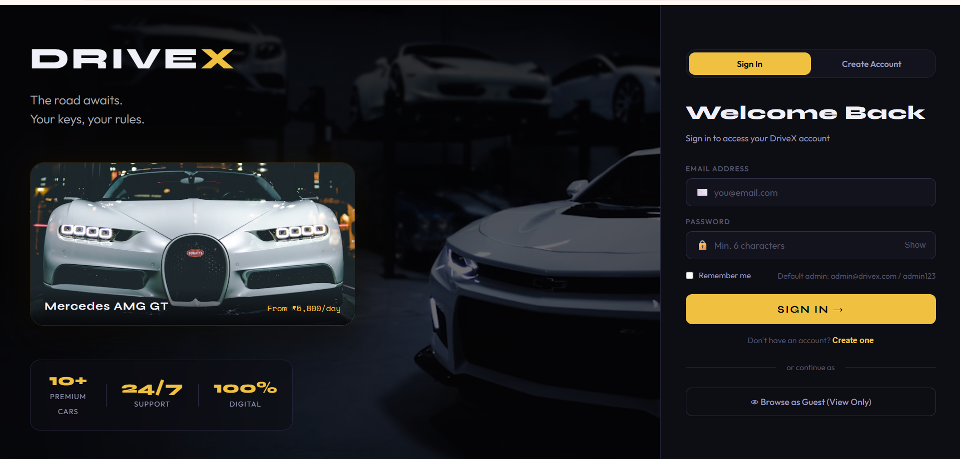
Figure 5.1:Login Screen
Inference
Explain what the screenshot demonstrates — e.g., “The login page validates user credentials, ensuring secure access. The design includes username and password fields, with error handling for invalid inputs. Also validation is carried out for all input fields.

CHAPTER 6
CONCLUSION
Minimum 300 words . Drive Now is a suitable academic project for demonstrating web application design in the domain of vehicle rental services. It combines user-centered design, modular frontend development, and simplified data handling to create a practical prototype.[1]
When organized according to the sample index, the project becomes clearer, more professional, and easier to evaluate. The structure used in this document follows the academic guideline while reducing the excessive repetition present in the original source material.[2][1]

CHAPTER 7
FUTURE ENHANCEMENTS
Minimum 300 words. Possible future improvements include secure login, real-time availability updates, payment gateway integration, booking history, cancellation handling, and administrator dashboards. These enhancements would extend the current prototype into a more complete production-ready rental platform.[1]
Additional improvements can also include stronger security controls, deployment on cloud infrastructure, mobile optimization, and analytics for business decisions. These align with the sample format's focus on performance, scalability, and maintainability.[2][1]

CHAPTER 8

REFERENCES

[1] https://react.dev

[2] https://www.hertz.com

[3] https://www.zoomcar.com

[4] https://github.com/rahuldkjain/car-rental-system

